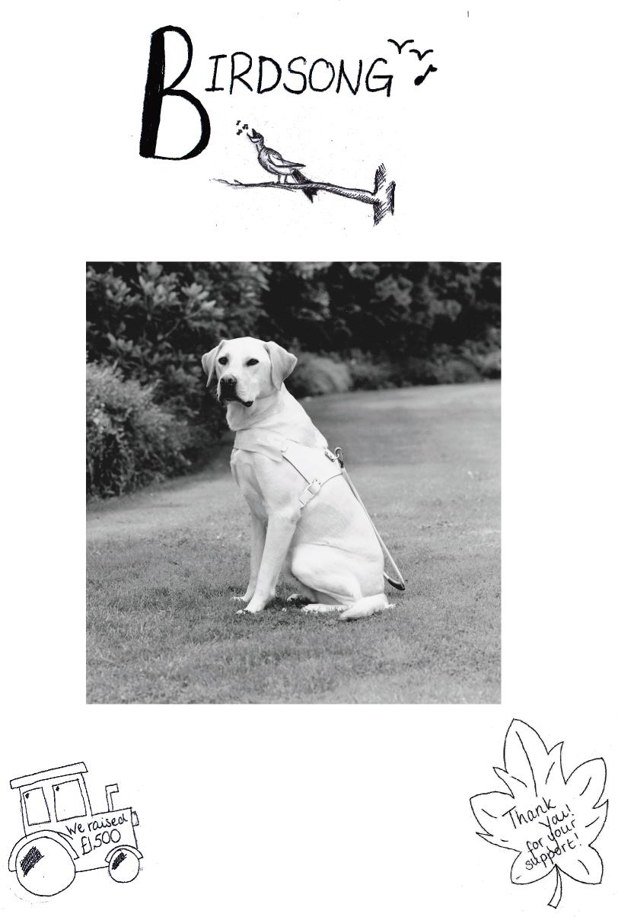
BIRDINGBURY NEWS
No. 58
SPECIAL YOUTH CLUB EDITION
Village Guide Dog, Birbury, Presented to
the village from ‘The Guide Dogs for the
Blind AssociaƟon’ ‐ 1993
October and November
2013

Birdingbury Parish Council Chairman’s Report September 2013
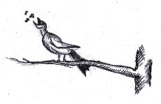
The Parish Council met again after the summer break on 17th September, with a range of important issues on the agenda.
Many of you may now be aware that this area of Warwickshire has been designated by the Coal Authority as a possible site for Underground Coal GasiÞcation (UCG) – a process by which deep coal measures can be exploited, under licence, to release gas resulting from partial combustion underground. Birdingbury is on the edge of this licence area. Already one company (Cluff Natural Resources) has applied to secure a conditional licence. This issue was discussed at length at our meeting and we committed ourselves to ensuring that villagers are kept informed, and we also wrote to the County Council (who would have to grant Planning Permission) expressing our concern about this project as it develops.
This matter will be discussed at our next meeting (15th October), so if you would like to hear more, please do come along. I and the other councillors would also be happy to hear from any parishioner on this before that meeting.
The recent inspection report on the Recreation Field was also discussed and action is being taken in line with that report. We raised with our local County Councillor, Howard Roberts, concerns about dangers of ßooding on Back Lane following heavy rain (as happened in late July). It appears that blocked drains on Main Street may be a signiÞcant cause, and we have chased this up , with an engineer visiting this week. We have plans to clean and renovate the War Memorial at the crossroads, and have sought quotations for doing this from specialist companies; we hope to get some grant towards the cost of this (over £1,000), but feel it is important to do this before more serious damage is caused. It will be good to have this completed in time for the centenary of the start of the 1914-1918 Great War next year.
Our Borough Councillor, Robin Hazelton ,reminded us that Rugby’s new Queen’s Jubilee Sports Centre is now open, and encouraged everyone to go and see (and try) the new facilities. He reminded us that this £12 million project is a great achievement in these times of council cutbacks.
The recent resignation of Councillor Chris Morton has led to the need to Þll the resulting ‘casual vacancy’. No requests were made to Rugby Borough Council for an election to be held, and therefore we have been seeking names of people who might consider being co-opted. So far we have had no names – leaving us with a Council of just FOUR members, which is not ideal.
Please see our separate notice which again asks for volunteers.
Do feel free to contact any of us about these or any other issues.
Diana Turner
Chair, Birdingbury Parish Council
WANTED!
A Volunteer to Þll the casual vacancy
on the Parish council
Are you interested in your community?
Would you consider being a Parish Councillor?
We meet on the third Tuesday of every month except August and December – at 7.30pm for around 90 minutes usually. Our role is to represent the Parish and to be sensitive to the needs of its inhabitants. We are consulted about Planning Applications, we chase up and lobby the Borough and County Councils about issues which they control (planning, highways, refuse collection, safety etc.) and we also have available (limited) resources to improve our environment (grass-cutting, recreation
facilities, paths etc).
It is important that your Council represents the WHOLE community, so ask yourself
whether you could be that representative!
Please talk to any councillor to discuss what is in‐
volved or contact
the Clerk: parishclerk@birdingbury.org

The Balloon Race
The highlight of the youth clubs’ fund raising for Guide Dogs for the Blind, was the Balloon Race launch that took place at the Birdingbury Coun‐ try Show. The finale was a great spectacle as five hundred multi coloured balloons drifted into the sky eastwardly. The release was followed by shouts of “Issie...Issie let GO! ” as her bracelet was caught in the net, emulating images from the film “Up”.
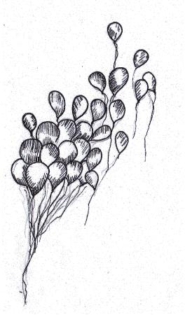
We have received 36 balloon labels and mapped their distance. Adjudicating the results has been interesting and intriguing –most balloons trav‐ elled south east but ONE rogue balloon was re‐ turned from Dorset. Has there been unfair practice at work or is it a miracu‐ lous anomaly?
One particularly amusing finder put their address as “My garden”. Another responder returned his found label together with a cash donation for the charity. The Hardy family who purchased five balloons had three of them returned.
Villagers whose balloons were returned:‐‐
Jake Thomas | St Albans | Leslie Turner | St Albans
Suzy Rawlings | Banbury | Henry French | Orpington
Kevin Gregory | London N21 | Oliver Taylor | Dunstable
Mark Taylor | Beaminster | Mark Taylor | Bushey, Herts
Diana Turner | London E17 | Kate French | Harpenden, Herts
Frankie Kerry | Ashton, Northants | Linda Turner | Milton Keynes
AND THE WINNER OF THE £50 PRIZE DONATED BY
THE FRIENDLY INN AT FRANKTON, IS:
MARK TAYLOR – BEAMINSTER, DORSET DT8 3BS
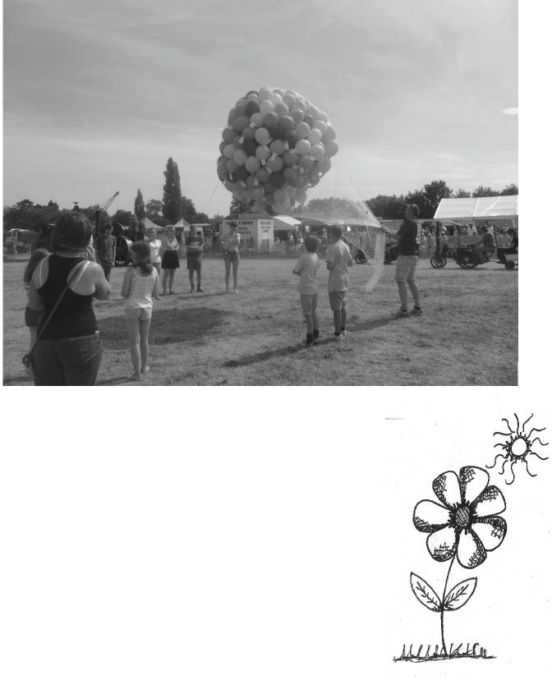
The Finder Judy Caen also will receive a £40 voucher.

THANK YOU TO EVERYONE WHO PURCHASED A
BALLOON AND EVERYONE WHO RETURNED LABELS.
£500 was raised for Guide Dogs for the Blind.
Henry French, Marcus and SebasƟan Coles

The Guide Dog AucƟon Meal
Birdingbury Country Show – 13th and 14th July
2013
The Show Committee have now finalised the financial matters for the event held in July, and are pleased to announce a profit of £10765.40. We were very lucky this year as the weather was so good. The profits will be distributed as follows:-
£3000 Warwickshire and Northamptonshire Air Ambulance  £3000 Cystic Fibrosis  £3000 Leukaemia and Lymphoma Research £200 Leamington Hastings Young Farmers Club £200 Birdingbury Community Distribution Fund | 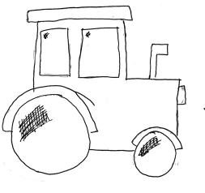

In addition, we were helped by local Scouts groups to whom we donated £1200 (before the profit figure). Birdingbury Youth Club also took part and raised money for Guide Dogs for the Blind, and there were six other charities represented raising monies for their particular cause. The remainder of the profit will be kept as reserved funds.
The Show Committee would like to thank all those involved. It has been decided to hold a Show on 12th and 13th July 2014 – and ideas and help would be greatly appreciated.
Birdingbury Country Show CommiƩee
This photograph has been selected by Leukaemia and Lymphoma Research to be used in their national publicity.  The photo features some of the Girls who ran the 'Garden Cafe' at the Show with the Mayor of Rugby;  Maggie Chinn, Sylvia Redhead, Gaynor Davy, Jan Seenan, Debbie East-Nuttall, Emma Hardy, Mayor of Rugby Councillor Anthony Gillias, Mrs Gillias and Bob Munro | 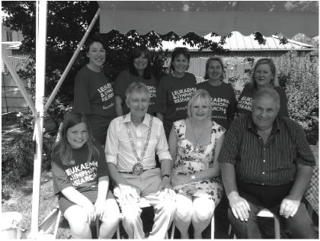

Barbara Munro
The chance of a dinner cooked by Alison Chappell proved to be the most competitive ‘prize’ at the auction, held during the ‘Party in the Park’ Scarecrow Spectacular in June. It was so competitive that on at least one occasion two members of the same team were bidding against each other! The dinner for 12, to be provided by Alison who, in her spare time, runs Chaturs, a home restaurant at Linden on Main Street. Chaturs has been a great way of Alison enjoying her love of making food combined with Cheryl enjoying her love of chatter! For the last 4 years, Cheryl and Alison have offered the restaurant to friends and family and raised over £400 for charity in the process. The auction on this occasion raised £250, and the table was set for 12 on Friday 20 September, at 7.30. A delicious mix of salmon, chicken, ricotta cheese and spinach was prepared as the main course, and the famous white chocolate and raspberry cheesecake was offered as dessert, along with a chocolate brownie concoction! The meal was rounded off with coffee and mints. Thanks to Alison for taking on this huge challenge, and Cheryl and Nushka (their dog) for going out for the night!
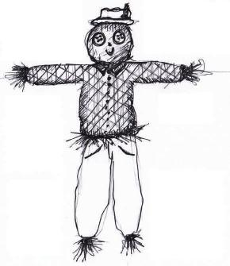
Evie Stuart
YOUTH CLUB— A visit from the Guide Dogs
Lynne Cannell visited Youth Club with Labrador puppy Foyle, to accept the cheque of £1,500 in support of Guide Dogs for the Blind. The sponsorship involves naming a Guide dog puppy and the last Guide Dog sponsored by Birdingbury residents was 20 years ago in 1993 and was named Birbury. After much deliberation, the Youth Club created a shortlist of names: Birdie, Leonard and Birders. We are now waiting for confirmation from Guide dogs for his/her name and will then invite the puppy to visit the Youth Club. Villagers will also be invited to come along and see the puppy . Anna French
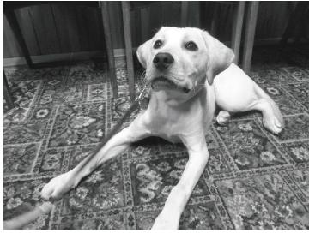

Ladies Circle - September

Big Dogs’ Breakfast
John and Lesley would like to extend a big ‘Thank You’ to all the dogs of Birdingbury who got up especially early on Saturday 31st August to bring their humans along to the Big Dogs’ Breakfast at Moonrakers.
This event was held to raise money and awareness for Dogs for the Disabled. This splendid organisation is a life-transforming charity, creating exceptional partnerships between people living with disability and specially trained assistance dogs. Through practical assistance a dog can offer freedom and independence to children and adults with physical disabilities and children with autism*.
All in all, we counted 232 legs with varying degrees of furriness, alongside 25 waggly tails and a fantastic £485 in the donations box. We have since had a lovely letter from Dogs for the Disabled expressing their appreciation of everyone’s generosity. Leslie Fleming
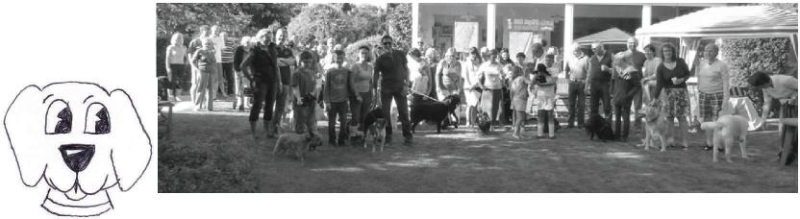
BIRDSONGBIRDSONGBIRDSONGBIRDSONG
The 'Pink' Charity Evening will be taking place on Thursday 17th October 8-10pm, Marton Village Hall, in aid of breakthroughs for Breast Cancer. There will be no charge for entry and a variety of entertainments will be on offer including refreshments, raffle and a variety of other stalls.
PINK CHARITY EVENT
For further information please contact Maria Leret TEL: 01926 633456
Everyone is welcome, so do please bring any family members along with you
The Annual General Meeting was held on Tuesday, 10th September. Attendance was quite low with apologies being sent due to holidays and illness. Jackie, as Treasurer, reported a healthy bank balance and it was agreed to leave the annual subscription as £10, and the visitors fee at £2 per meeting. The ‘Officers’ agreed to stand for another year and remain as Jackie Westcott - Treasurer, Maggie Chinn – Secretary, Barbara Munro – Chairperson. As Maggie was unable to attend, the Secretary’s report was held over until the October meeting. The programme of events will also be completed in October when, hopefully, more members will be able to attend.
₈th
The next meeting is on Tuesday, October, at 7.45 p.m. in The Birbury. Lady Kira Dalton
will talk about her work with the African Trust in Gambia. Kira last spoke at Ladies Circle in October 2011 so it will be interesting to hear how things have progressed in the last two years. Visitors are most welcome.
The subject of the November meeting has not yet been Þnalised and will therefore, be publicised on the village notice board nearer the time.
Barbara Munro
BIRDSONGBIRDSONGBIRDSONGBIRDSONG
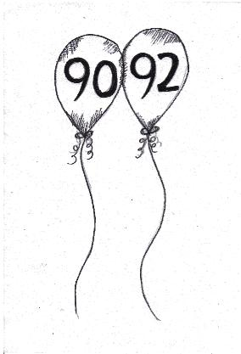
Birthday CongratulaƟons to Bill Cowley and Dink To all our good friends in Birdingbury
I would like to say thanks for the wonderful 90th birthday messages and pressies. To really make our day, our one and only grandchild, our granddaughter called Terry, arrived with some of her offspring. On my count there were Þve generations under one roof. I can assure you all it was a fantastic day. To top it all I went to swap shop the next day and was greeted with the birthday anthem, and more cards and pressies. I received forty two cards altogether. I am so glad we decided to live in this village after I was demobbed in 1946. After all that I would like to say "Happy Birthday" to my dear wife Dink whose 92nd birthday is on 13th October.
Bill Cowley

The Birdingbury Club
“Birdingbury Film Nights'. Our first ever film show was so well received by all who aƩended we just had to repeat it. For those who didn't, we hired in a professional company who provided a screen which covered the end wall, high quality Blue Ray projec‐ Ɵon and Surround Sound so it felt just like being in the cinema but this Ɵme right on your doorstep. We have signed up for three films, which will be shown on Saturday 16th No‐ vember, Saturday 25th January and Saturday 29th March. We haven't chosen the films yet so if you want to influence our decision E Mail birdingburyclub@gmail.com.
We will circulate details of this years’ village Bonfire Night, which will be on Saturday 9th November, as soon as they are finalised. And, Christmas isn't far away so remember to check out the next Birdsong for details of Decembers’ family events to be held on Saturday 21st and another lavish NYE celebraƟon".
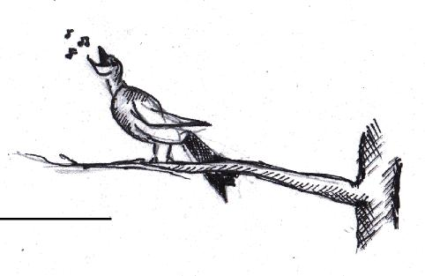
Ian Tipton President
Come in from the cold to Church Café 16th November, 12 and 2 o’clock in St. Leonard’s
We are combining a ‘Made in Birdingbury’ lunch of homemade soup, bread and cheese with a coat and jacket collecƟon for Hope4.
Bring along any surplus jackets or coats which we will pass them on to Hope4 for needy people in Rugby ‐ and join us for a lunch to warm you up too. If next winter is anything like last winter, then your donaƟons will be extremely useful to Hope4 in Rugby. All lunch donaƟons will also go to Hope4.
We look forward to your company: see you on the 16th.
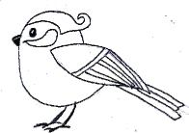
Hadrian’s Wall Charity Walk
Well done to Sophia Foroughi and Lizzie Morton who completed walking the 84 miles of Hadrian’s Wall in just over 5 days raising nearly £2000 for Young Epilepsy & Epilep‐ sy AcƟon. ‘Thank you so much to all the villagers who sponsored them for such a good cause. Fortunately the weather was kind ‘it was hard work but so worthwhile’, they commented.
Many thanks Chris Morton
BIRDSONGBIRDSONGBIRDSONGBIRDSONG Clear Out Before Christmas?
I work with a school in the town of Geita, in northern Tanzania , to send out class‐ room resources. Hugh and I have had a long associaƟon with the town going back 20 years. We lived and worked there for seven years as geologists on a gold exploraƟon project and it’s where our daughter took her first steps. The school has extremely limited resources but is fortunate in having a very dedicated teaching staff. My aim is to provide them with resources they are unable to access themselves, and that, un‐ fortunately, includes the most basic of items. If you, or any family and friends, have any of the following that need a good home then I would love to hear from you.
Toys suitable for recepƟon age groups upwards. These can include (I was going
to put a list here but really anything is useful as they have nothing). Books of course, again anything can be of use, ficƟon/non‐ficƟon. They have no sports equipment so anything like skipping ropes would be great and musical instruments.
As you can see the wish list is as broad as it is long so if you can help it will all go somewhere where it will have a long and useful life.

Jan 633514
Aileen and Eira

Duke of Edinburgh Experiences

My Weather Station
by Henry French
I have a weather station in my garden that transmits data from outside to a receiver inside. It has  an anemometer to measure wind speed and wind direction, a rain gauge and temperature, pressure  and humidity sensors. At school, I work at the Weather station, where we collect weather relat-  ed data from the previous day. The warmest  ₁st  day in August was the August when there was a maximum of 31.1ûc. | 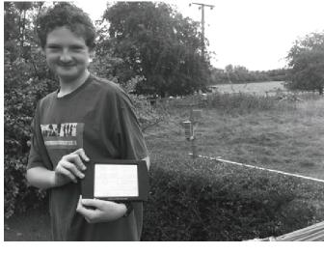
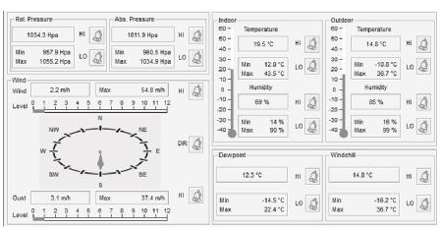 |  | At home, I use a program called Easy Weather, and when I plug the receiver into the computer and load up I get a page showing the temperature, humidity, wind speed and direction and pressure at that moment in time. The picture on the left displays the weather on the 21st September.

This summer, Anna French and I, completed our qualifying expeditions for our Duke of Edinburgh awards, Gold for Anna and Silver for me.
This meant we had to trek round welsh mountains and valleys with only a rucksack and a map for 5 days, carrying all our own food, tent, sleeping bag, clothes in this one rucksack.
As you’d expect in Britain, the weather was of course not always kind to us on our expeditions.
Anna, who was completing Gold, had two days of solid rain, 1 average day, and 2 days of blazing sun. I, completing silver, had 4 full days of blazing sunshine with temperatures reaching 29°C, which felt like 640°C with a 6 stone rucksack on my back. Anna also suffered from a horrible case of trench foot.
However, in spite of the awful conditions, we both did witness some absolutely gorgeous sights whilst on our separate journeys – it’s just a shame we couldn’t appreciate them at the time. Our only goals seemed to be set on the Þnish line (or food, camp or water...)

I can then search for a speciÞc time period, from one hour to one year, and look at the results. This picture is showing the humidity and temperature on the 18th of September 2013. The coldest night in August fell down to 8.8ûc on the 13th. |  | 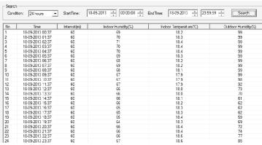 | It was certainly an interesting experience and I would deÞnitely encourage young people in the village to think about participating in doing their Duke of Edinburgh awards, despite the dreaded expeditions!  Issie SharraƩ  BIRDSONGBIRDSONGBIRDSONGBIRDSONG  HOUSING NEEDS SURVEY |  | 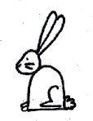
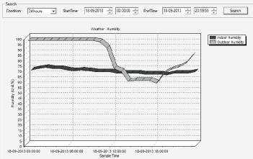 | Furthermore, I can also create graphs of the data on my software. The graph to the left shows the indoor and outdoor humidity on the 18th of September. August saw 49.3mm of rain which is 23% below the average from 1918-2010 with 25.8mm of rain falling on the 15th. |  |  | Delivered with this months Birdsong is a Village Housing Needs Survey. Please complete and return in the prepaid, addressed envelope.

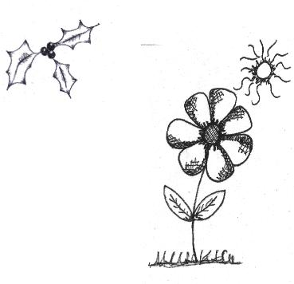
La Posada returns to Birdingbury
Last year we tried a new way of looking forward to Christmas with the help of a travelling nativity set called a Posada. The idea comes from a tiny village in Spain and it's a special way for a community to celebrate the start of the Christmas season. A small nativity set, Mary, Joseph and a small battery operated lantern, travels between homes in the village to represent Mary and Joseph's journey to Bethlehem.
Last year we organised a rota for willing homes to give it shelter overnight, if possible in a window where it could be seen from outside, before passing it on to the next lodgings. This is an opportunity for a chat, a drink and a mince pie or whatever with your fellow villagers as you meet and greet to exchange the Posada. Don't worry if you can't get out, we can arrange collection or delivery.
If you're having a village event and would like the Posada to join you there please let us know, our set even went Carol singing round the village last year! We'd love you to be involved with its journey round the village before its arrival in church on Christmas Eve but we only have 24 spaces on our rota so that's why we're telling you about this now.
Please contact Jenny Hawes j.x.hawes@btinternet.com, 632678 or Josie Price, josieprice@tiscali.co.uk , 632545 if you'd like to book a slot between the 1st and the 24th December. We also need to know the dates when you cannot have the Posada so that we can - hopefully - arrange a rota that works!
We look forward to hearing from you...
COFFEE MORNING AT THE BIRBURY SATURDAY,12th OCTOBER@10.30a.m. BRING and BUY, CAKES, PHOENIX CARDS.
IN AID OF BIRMINGHAM CHILDREN'S HOSPITAL + CANCER RESEARCH.
I WOULD BE GRATEFUL FOR DONATIONS OF CAKES AND RAFFLE PRIZES. YOUR SUPPORT WOULD BE MUCH APPRECIATED
Liz Tompkins
Children in Need—Youth Club Event
Come along to the Youth Club Pudsey Bear Café, on Saturday 23rd November from 10:30
to 12:00. As well as delicious homemade cakes and lovely cups of tea and
coffee, we will be celebrating our achievement for raising £1500 for Guide
Dogs. We are hoping that we will be able to invite him to the event so that
the whole village will be able greet the villages’ second guide dog, incorpo-
rating the grand naming of the Birdingbury Village Guide Dog.
The morning will include a variety of activities including fun games, a chocolate fountain, a chocolate tombola, a children’s lucky dip, a children’s raffle and a children’s bookstore.
TEENAGE GUIDE TO MODERN VOCABULARY
Word Teenagers Rest of the PopulaƟon
Sick Really Good Unwell
Wicked Good Evil
Butters Ugly Dairy Product for your Toast
Spam Dodgy Email Dodgy Meat Product
Bro Friend Male Sibling
Man’s I/Me Masculine Pronoun
Beef Problem With Bovine Meat
Hashtag (#) Of the moment, twitter A redundant button on your
phone
Burn Insult To heat something to
excess
Bare Lots of Sparse

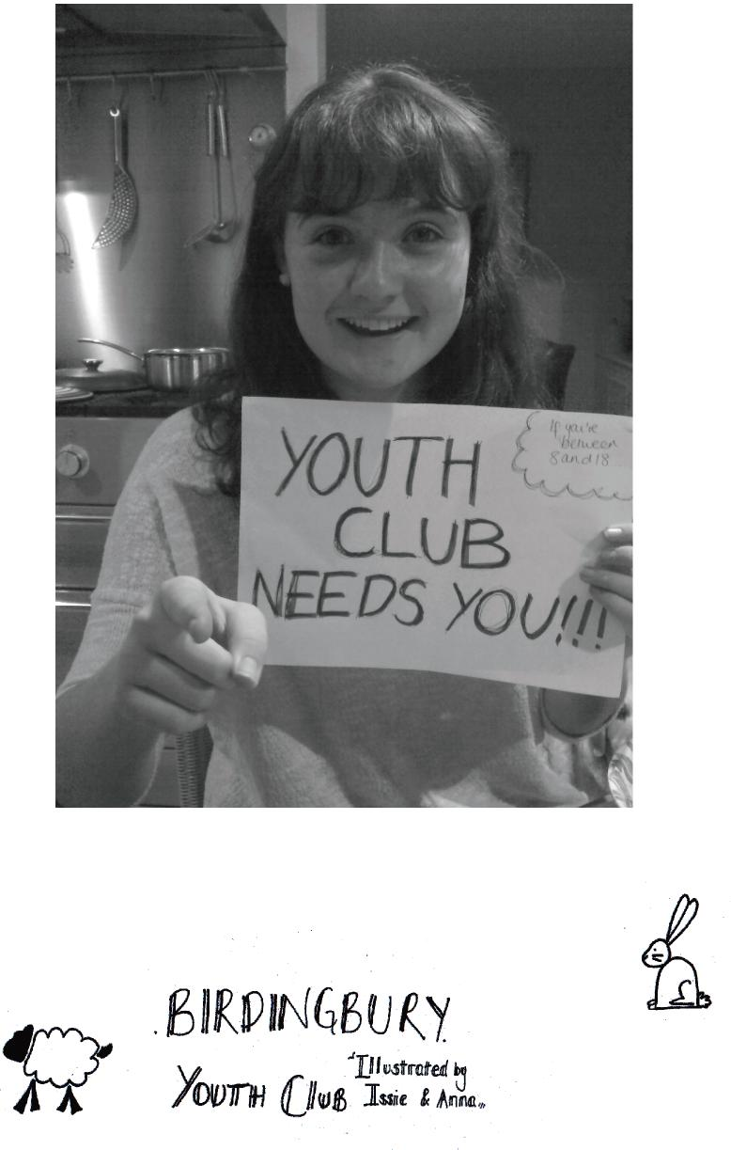
Compiled by: Marcus Coles
Birdsong Editors: Rhondda Barney, The Barn, Back Lane Tel 632094
Email: birdsong1@bƟnternet.com
Church News Editor: Aileen Withington, Marton Glebe Farm Tel 632644 Email: awchurchnews@hotmail.co.uk
Copy date for next issue:
18th November 2013

