BIRDINGBURY 100 YEARS AGO

The Birdingbury History Group proudly presents their latest exhibition in the Birbury and Club on Saturday 13th May 2017 from 11am to 4pm.

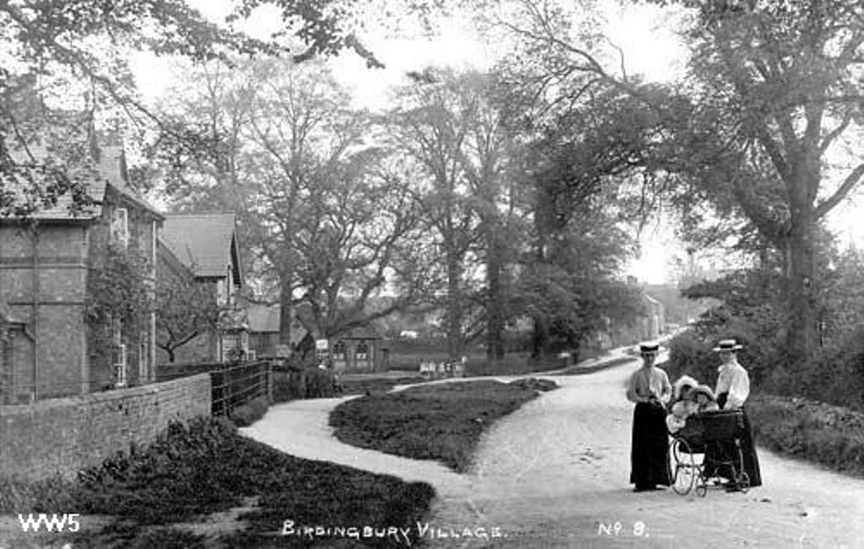

Come along and see what the village looked like in the period 1910-1918:

Who was living in your house?
What jobs did villagers do?
What were living conditions like?
Where did villagers do their shopping?
Who was living at Birdingbury Hall and what impact did it have on village life?
Where did the children go to school?
What impact did the First World War have on the village?
What role did the Church play in village life?
How important was farming to our village community?

The answers to these and many, many others will be found at our next open day on the 13th May. Entrance is free but we ask for a contribution, if you are able, towards the costs of producing the exhibition.
Refreshments will be available
Please join us if you can to celebrate the centenary of our lovely village.

